**SuperScan Automation Application**

(Ver 2.3.0)

**Overview**

SuperScan is a Windows-compatible application whose purpose is to automate the search for supernova suspects using the TheSkyX™ Professional astroimaging platform.

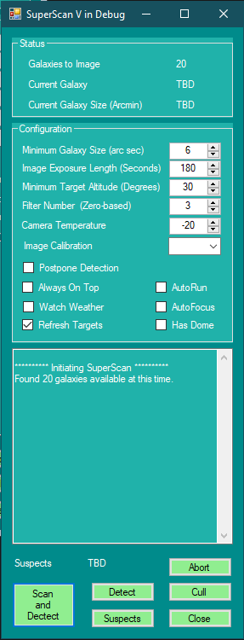

Each night that SuperScan is run, a fresh set of images is taken of all available galaxies that fit a set of user-stipulated criteria. Each galactic image is compared against the most recent equivalent image from a prior SuperScan run. If any new light sources appear within the boundaries of the imaged galaxy, their location is derived and flagged. Upon completion of a scan, the images that contain flagged suspects are displayed for visual analysis and any follow up work a user might want to prove the source real.

As options, SuperScan supports variable exposure length, autofocus, delayed start, execution of pre-scan and post-scan automation scripts, minimum altitude limit, and filter selection. Additional constraints on the galaxy selection can be made by modifications to the SuperScan database search query.

**Description**

For each night’s session, SuperScan uses TheSkyX™ to generate a list of imageable target galaxies in the form of a constrained Observing List (or uses previous list – see below). For each target galaxy, SuperScan takes and stores an image using a single filter, normally clear. Unless this is the first image of that galaxy, a prior image is aligned and subtracted from the current image leaving an image of residual light sources. These remaining light sources are compared against cataloged star positions. If an unexpected light source is detected, then the target is flagged for the user’s subsequent attention as a “suspect” whereupon a 10 minute exposure is imaged and stored for subsequent review.

Once the light source processing on the set of galaxies is completed, the list of galaxies containing suspect light sources is available for visual analysis. The light source anomaly is centered on the TSX chart. Then, using Plane Wave PlateSolve2, the long exposure with pointers to the suspect location is displayed. The Transient Name Server is queried for recent reports of supernova events for this galaxy. The RA/Dec position of the light source is saved to the clipboard. Using the Blink command, the user can also compare rapid overlays of the current and prior images.

The user can then mark the suspect as cleared or leave for follow up imaging and analysis. Suspect information is retained in an XML file.

If the user wishes to optimize the use of available imaging time during a scan, the detection function of SuperScan can be suspended. Detection of light sources can take up to several minutes for each target depending upon computer capabilities. At a later time, the detection function can be executed. In this mode, no images are acquired, but the two most recent images for every galaxy in the image bank are compared and analyzed.

The scan does not use autoguiding but relies on the inherent tracking precision of mounts such as the Software Bisque Paramount™ family. Once such a mount is fully dialed-in, images of up to five minutes exhibit light source trailing artifacts that are indistinguishable from the noise contributions of seeing and bloom. This attribute may limit the minimum magnitude of viable targets, but significantly reduces the complexity of targeting, as well as improves its speed and reliability.

SuperScan attempts to minimize slew distances and meridian flips. After a galaxy is imaged, the next galaxy selected will be the closest unimaged galaxy that is on the same side of the meridian as the last, and is still above the minimum altitude. When the last galaxy on one side of the meridian is imaged, the scan will continue with the northern-most image on the opposite side of the meridian

By way of configuration, the user may choose exposure time, minimum target altitude and imaging filter. The user can also modify the galaxy search query to control the characteristics of the galaxies chosen for scanning.

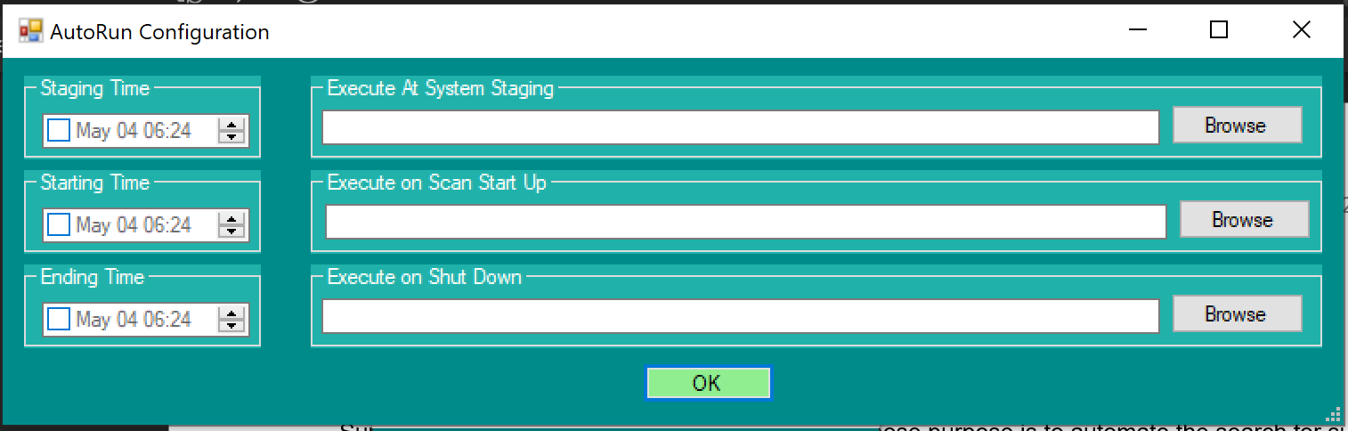

Another feature is the capability to run start the galaxy scan at a user-defined time. When using “AutoStart”, the user sets the start time and selects optional, user-built, automation script files for running before and after the galaxy scan. These scripts can be used for opening and closing a dome, for instance. If any the “Times” are set to a date/time earlier than the current date/time, then the Staging and Starting date/times are reset to the current date/time and the Ending Time is set to the morning of the current overnighter.

If AutoRun has been previously selected, SuperScan will open with this window automatically in the expectation that the Autorun configuration times will need resetting for the current run.

A user can also choose to have TSX refocus the camera (using @Focus2) upon initialization and whenever the focus temperature changes by at least one degree.

Lastly, the user can choose for the form to always be visible (Always On Top), have SuperScan monitor and take action on weather events (Watch Weather), and control a dome (Dome).

Information on how to assess and report new astronomical discoveries can be found at:

<https://www.iau.org/public/themes/discoveries/>

**Configuration**

* Exposure Time: Sets the length of exposure in seconds for each image
* Minimum Altitude: Restricts galaxy targets to this lower limit. Important over long scans.
* Filter Number: Sets the filter to be used for all images during the scan. Zero-based.
* Postpone Detection: Images will not be tested for anomalies during the scan. Saves some time.
* AutoFocus: The camera will be focused at the start and whenever the temperature changes by one degree while the scan is underway.
* AutoStart: The scan will start at a time designated in a pop up window. Optionally a pre-scan and post-scan application can be configured to run using the same window.
* Always On Top: The SuperScan application window will always show on top of all other windows.
* Watch Weather: An AAG CloudWatcher file is monitored for unsate weather conditions.
* Calibration: Choose the image reduction type: None, Auto or Full. Auto is recommended.
* Refresh Targets: If selected, SuperScan gets a fresh list of observable galaxies from TSX using the SuperScan database query. If not, SuperScans reads in a saved Observation List from the file SuperScanObservationList.txt. This file must be previously created and exported using the SuperScan query in the Observing List Management windows. This file can repeatedly imported to TSX Observing List Management for addition and/or deletion of targets, but must be exported again after changes.

**Command Buttons**

* Scan and Detect: Starts the scan. Each image will be tested for anomalous light sources after imaging, unless Postpone Detection is selected.
* Detect: Detection will be run on the most recent two images in the image Bank galaxy folders. This command is normally run after a scan with Postpone Detection set, say, in the morning.
* Suspects: A popup window is generated wherein the user can select logged suspects for further review. Once selected, TSX will display the cropped reference, current and difference images and configure the sky chart to show the location of the anomaly.
* Cull: Remove all but the clearest images for each of the galaxies from the image bank.
* Close: Ends the SuperScan session. Close also serves to abort the scan session after completion of the current image capture, if desired.
* Abort: Terminates the scan and closes the session, as soon as possible.

**Requirements**

SuperScan is a Windows Forms executable, written in Visual C#. The app requires TheSkyX Professional (Build 10837 or later) with the TSX Camera Add-On option. The application runs as an uncertified, standalone application under Windows 7, 8 and 10.

Upon Version 2.0, SuperScan requires PlaneWave PlateSolve2 V2.28 or later to display, align and blink suspected light sources. PlateSolve2 is downloadable for free from the PlaneWave support site.

SuperScan has been validated on a Paramount™ MX+. The developer assumes that other precision mounts from such vendors as AstroPhysics can also support accurate imaging over longer exposures without autoguiding, but makes no guarantees.

**Installation**

Download the SuperScan_Exe.zip and open. Run the "Setup" application. Upon completion, an application icon will have been added to the start menu under "TSXToolKit" with the name "SuperScan". This application can be pinned to the Start if desired.

**Support**

This application was written for the public domain and as such is unsupported. The developer would happily entertain questions or suggestions, and may update the application occasionally as time permits. Otherwise, the developer wishes you his best and hopes everything works out, but recommends learning Visual C# (it's not hard and the tools are free from Microsoft) if you find a problem or want to add features. The source is supplied as a Visual Studio project.

**Detailed Description**

Configuration and Initialization

Data File Structure

SuperScan files are stored in the user’s Documents folder in a folder named “SuperScan”. In this folder will be stored:

* A directory named “Logs” containing daily log files::
  + Text-based log files with dated names: “dd_mmm_yyyy.txt”
* A directory named “Image Bank” containing galaxy image directories:
  + Directories with the name “NGC xxxx” where xxxx is the NGC number.: Within each directory are the galaxy images.
    - Uncropped images with naming format:

“NGC xxxx_yyyy-MM-dd HHmm.fit”

* Cropped image of most recent image: “CurrentImage.fit”
* Cropped image of next most recent image “Reference.fit”
* Cropped image of difference image: “Difference.fit”

* An XML-based configuration file named “SuperScanCfg.xml”
* An XML-based suspect file named “suspects.xml”

Focus:

When selected, @Focus2 is run at the beginning of a scan and whenever the temperature (measured at the focuser) changes by one degree. TSX should be configured to choose and slew to the focus star.

Rotation:

SuperScan adjusts for differences between image PA when comparing sequential images

Filter:

The user can configure the filter to be used for the SuperScan session, based on a zero-based filter number in the filter wheel. Normally, this would be the Clear or Luminance filter as it provides for the fastest imaging, but the user may choose some other filter for some other reason

Exposure:

Exposure time can be set by the user, and normally should be set between 3 and 5 minutes. The automatic light source detection routine will compensate for some variation in brightness between subsequent images of the same, but not too much variation will cause false positives or negatives.. So, the exposure time should be set and left for all sessions. This may be improved upon in the future. Maybe not.

AutoStart

A checkbox determines if SuperScan will delay until a proscribed time to begin scanning. If AutoStart is selected, a configuration window will pop up for the user to enter the location of an executable file to run just before the galaxy scan, the location of an executable file to run just after the galaxy scan, and the time to start the scan. If the time entered is earlier than the current time, then the start time will be set for the next day, e.g. after midnight of the current day.

Always On Top:

Select to keep the app showing at all times.

Weather Watch:

Select to monitor a Cloud Watcher type folder for unsafe weather events. Will close dome if dome is selected in the event of unsafe weather. Will close, and reopen, during cloudiness event.

Dome:

Select to turn on dome management. Works in conjunction with Weather Watch to close (and reopen) a dome cover if needed.

Galaxy List Generation

The galaxy list is driven by a custom TheSkyX™ Observing List query “SuperScanQuery.dbs”. This query searches the NGC catalog for all galaxies, within the user’s local horizon whose:

* Major axis size exceeds 5 arcseconds.
* Magnitude is greater than 14.
* Altitude is greater than 30°.

These query parameters will produce on the order of 10 to 150 target galaxies, that require up to four hours of scan time at an exposure time of 60 seconds. The query parameters can be manually changed by the user if desired by using the TSX Manage Observing List function. Future versions of SuperScan may make this query more easily configurable. Maybe not.

Fresh Image Collection

For each galaxy in the list, SuperScan performs a Closed Loop Slew to the galaxy location as defined by the TSX Find function. Then,

* + - Calibration is set for AutoDark – no options.
    - Filter is unchanged.
    - Exposure time – see Configuration.

The image is taken asynchronously although SuperScan has nothing else to do while waiting, for now.. Aborts are not supported at this time. Upon completion, the image is stored as a temporary file in anticipation of comparison with a previous image.

Galaxy Image Bank

The Image Bank is a set of folders where previously taken images of each galaxy are sorted and stored. Each folder is named with the NGC number of the galaxy, e.g. “NGC 2331” to allow easy lookup. See Configuration. Once an imaged is processed, it is stored in the Image Bank.

New Light Source Detection

SuperScan expects a supernova explosion to appear as a new, stellar-size light source within a galactic image. “New” in this case means that TSX astrometry (Image Link) detects a light source the current image that is not detected in the most recent prior image. “Within the galactic image” means that the light source is within the area of the galaxy as defined by the major and minor axis.

For each galaxy imaged during a session, SuperScan adjusts the two images to a minimum overall pixel difference:

1. Extract TSX WCS Inventory information to determine relative rotation and translation
2. Crop images based on galaxy major axis. Convert cropped images to image arrays and apply bias, rotation and translation adjustments.
3. Compare average pixel values (TSX) to determine relative image exposure levels.
4. Adjust and subtract cropped reference image from current image. Save the cropped reference, current and difference images as fits files in the galaxy’s Image Bank folder.
5. Remaining light sources are extracted from the difference image. Their location is compared with cropped reference image light sources. If a difference image light sources has no reference image light sources near it, then it is flagged, x/y location on the difference image recorded and RA/Dec location from the current image computed.
6. The session moves on to the next galaxy.

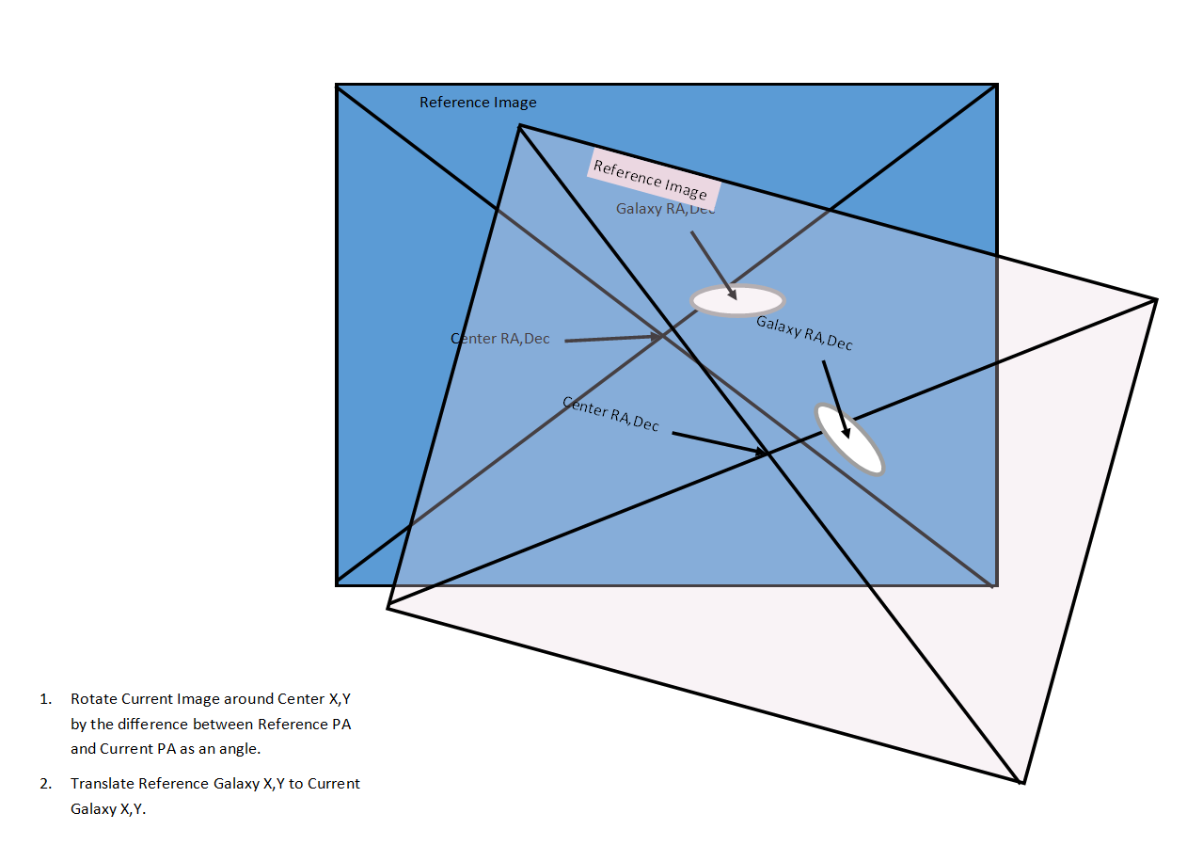

Suspect Review

Upon completion of an Evaluation (anomalous light source detection), information about the suspect light source is stored in an XML file: Suspects.xml. Each entry includes the galaxy name, image time and position of the suspect light source. Upon selection of a suspect entry, SuperScan uses PlateSolve2 to display the current image with cross hairs on the position on the suspect light source. The TSX chart is centered on the suspect position and FOV is set to the size of the associated galaxy, such that the images can be visually analyzed. In addition, a web query is sent to the Transient Name Server that will return and display any recent posting for a transient event in the target galaxy. If “Blink” is selected, then the current image display is alternated with the next most recent image display. Warning: the set up on Blink is slow. Be patient. Upon completion, the status of the suspect can be set to “Cleared” or left “Suspected” for later analysis.

Cull Images

Over time, galaxy images build up for no particularly good reason. Cull images allows the user to delete all but the best image of the set. It is recommended that the user back up the whole image bank folder before culling, if there is a chance that any image but the best is going to be wanted in the future. For each galaxy directory in the Image Bank, Cull Images will Image Link each image and assess the star count. All images except the image with the maximum star count will be deleted. This process is also useful for removing old images taken during periods of poor visibility.

Logging

SuperScan maintains an xml-based session log in the base folder under the filenames called “SuperScan<date>.xml”. Progress is also logged to a text box in the main window.

Change Log

V1.0 -- 7/20/17

1. Release on Software Bisque support forum

v1.1 -- 7-27/17

1. Modified SuspectReport to display "no prospect" when no prospects are in the prospect XML file,
2. Added description headers where missing.
3. Changed SuperScanConfiguration class name to just Configuration
4. Renamed TSXPrep.Telescope to TSXPrep.TelescopeStartUp
5. Added TSXPrep.TelescopeShutDown method (for scope parking)
6. Renamed TSXPrep class to DeviceControl

1.2 -- 8/15/17

1. Restructured the AutoStart configuration and operation:
   1. Added a configuration item to save a system staging filepath and run time.
   2. Added a configuration item to save a drop-dead time for the SuperScan
   3. Added paths to run for each of the staging, start up and shut down executables
   4. Added checkboxes to enable each in the autorun configuration
   5. Changed AutoRun to segue into the scanner, and have the scanner check for the
2. end time after every cycle.
3. Fixed the galaxy done counter.
4. Added feature where suspect RA/Dec is copied to the clipboard for use in WikiSky, etc.

1.3 -- 8/16/17

1. Major modifications to the SuperScanForm and SuspectReportForm
   1. SuperScanForm: added a subroutine to take a 10 minute deep image whenever a suspect is detected.
2. The image is stored inside a new subdirectory in SuperScan called FollowUp/MM-DD-YY/. This
3. subdirectory can be used to store other related files if needed.
   1. SuspectReportForm: deleted code to display reference, difference and current images on TSX.
   2. SuspectReportForm: added code to display the deep image, centering on the suspect location.
4. The RA/Dec location will be loaded in the clipboard for use in WikiSky.
   1. Configuration: Added configuration filename methods and file structures.
   2. Created own version of FindNearest -- TSX's version does not have control of the nearness.

1.4 -- 9/7/17

1. Changed the autorun such that the galaxy list was redone upon starting up.

-- 9/10/17

1. Added Weather Check

-- 12/28/17

1. Fixed so Mininmum Altitude could be set/changed
2. Added check for current altitude. Logged and skipped if too low.
3. Added slew before CLS because TSX was not waiting for dome slew before initiating image.

12/29/1

1. Fixed CLS slew, again (and actually tested it)
2. Fixed starting time calculation so that if the starting time is in the AM, then it is made the next day.
3. Added commands to connect to and couple a dome, if present
4. Added color to scan button to indicate that a scan is underway
5. Added an abort button -- mostly just closes the app when it can

1.8 -- 1/1/18

1. Added AAGCloudWatcher ASCOM weather monitor and safety (e.g. weather) checks]\

1.9 == 1/17/18

1. Added Minimum Galaxy Size setting

1.9.1 -- 3/30/18

1. 1.Added search for last image to look in O: drive
2. Modified AutoFocus to move off the meridian to no more than 80 degrees altitude to avoid a meridian flip

1.9.2 -- 8/16/18

1. Added wait before IsDomeClosed and IsDomeOpened check because of inability of TSX or ASCOM driver tohandle with out throwing exception

1.9.3 -- 9/26/18

1. 1.Changed "Threading.Sleep" to "Task.Delay" in FreshImage to allow moving the form around during image capture
2. 2.Added WatchWeather as a checkbox and stored in configuration to disable weather monitoring function

1.9.4 -- 10/28/18

1. 1.Changed the unsafe weather procedure to park the telescope -- to keep it from continuing to track

1.10.0 -- 12/1/18

1. Added the avoidance code to prevent an Error 123 from blowing up a CLS
2. Modified the Suspect Report to handle a thrown Image Link/Show Inventory exception.
3. Modified the Suspect Report to update and redisplay the suspect list after a suspect has been cleared.

1.11.0 -- 10/30/19

1. Added code to continue to try to close dome in the event of a dome close failure.

2.0.1 -- 11/11/19

1. Modified Suspect routines to add blink capability on last two images. Now requires Planewave PlateSolve2 for operation.

2.0.2 -- 12/28/19

1. Fix problem where Shut Down time would not reset to the following day, and generally cleaned up that code so the default and update dates made more sense.
2. Moved change log from code to this document
3. Updated description of Suspect Search in these instructions.

2.1.0 -- Not sure what I did

2.2.0

1. Added CullImage static class to clear old images.

2. Added wait warning for suspect processing and blink and cull image.

2.3.0

1. Changed “SuperScanForm” name to “FormSuperScan” to make it easier to find in the list.

2. Changed the way check items “Dome”, “AutoRun”, and “FormOnTop” are restored on launch (from the “configuration.xml file) so these configuration items propagate with each launch of the app.

3. Updated this doc.

------------------------------------------------------------------------